**SERVICE MANAGEMENT SYSTEM**

**CORE TRANSACTION**

(**RECRUITMENT, APPLICANT MANAGEMENT, NEW HIRE ON BOARD, EMPLOYEE MANAGEMENT, RECRUITING ANALYTICS & REPORTING, POSITION / JOB MANAGEMENT, PAYROLL & PAYMENT MANAGEMENT, PLACEMENT MANAGEMENT, CLIENTS MANAGEMENT, CLIENTS AGREEMENTS AND CONTRACT MANAGEMENT.** )

A Project Study  
Presented to the IT Project Evaluation Committee  
Bestlink College of the Philippines  
Quezon City, Philippines  
in Partial Fulfillment of the Requirements for the Degree  
Bachelor of Science in Information Technology

By

Jericho Alibadbad

Paul Dexter Dolientas

Jullius Frias

Zelden Pamplona

Dandy Antojado

**TABLE OF CONTENT**

1. Project Management 2

1.1 Business Case 2

1.1.1.1 Executive summary 2

1.1.1.2 Business case analysis team 3

1.1.1.3 Problem definition 4

1.1.1.4 Project Overview 8

1.1.1.5 Strategic Alignment 11

1.1.1.6 Cost-benefit analysis 11

1.1.1.7 Approvals 11

1.1.2 Project charter 11

1.1.3 Stakeholder Strategy 11

1.1.3.1 Introduction 11

1.1.3.2 Identify stakeholders 12

1.1.3.3 Key stakeholders 12

1.1.3.4 Stakeholder analyst 13

1.2 Project Planning 13

1.2.1 Project management plan 13

1.2.1.1 Introduction 13

1.2.1.2 Project management approach 14

1.2.1.3 Project scope 15

1.2.1.4 Milestone list 15

1.2.1.5 Schedule baseline and WBS 15

1.2.1.6 Change management plan 15

1.2.1.7 Communication Management Plan 15

1.2.1.8 Cost management plan 15

1.2.1.9 Procurement Management Plan 15

1.2.1.10 Project scope management plan 15

1.2.1.11 Schedule management plan 15

1.2.1.12 Quality management plan 15

1.2.1.13 Risk management plan 15

1.2.1.14 Risk Register 15

1.2.1.15 Staffing Management Plan 15

1.2.1.16 Cost Baseline 15

1.2.1.17 Quality Baseline 15

1.2.2 Risk management plan 15

1.2.2.1 Introduction 17

1.2.2.2 Top three risk 17

1.2.2.3 Risk management approach 17

1.2.2.4 Risk identification 17

1.2.2.5 Risk Qualification ad Prioritization 17

1.2.2.6 Risk Monitoring 17

1.2.2.7 Risk Mitigation and Avoidance 17

1.2.2.8 Risk Register 17

1.2.3 Scope management plan 17

1.2.3.1 Introduction 17

1.2.3.2 Scope management approach 18

1.2.3.3 Roles and responsibilities 18

1.2.3.4 Scope definition 18

1.2.3.5 Project scope statement 18

1.2.3.6 WBS 18

1.2.3.7 Scope verification 19

1.2.3.8 Scope control 19

1.3 Project Execution plan 19

1.3.1 Implementation and migration plan 19

1.3.1.1 Purpose 19

1.3.1.2 Description of implementation 19

1.3.1.3 Points of contact 19

1.3.1.4 Major task 19

1.3.1.5 Implementation Schedule 19

1.3.1.6 Security 19

1.3.1.7 Implementation Support 19

1.3.1.8 Listing of hardware, software and facilities 19

1.3.1.9 Performance Monitoring 19

1.3.1.10 Implementation Requirements (Hardware/Software/ Personnel/ Facilities/ other capital investment: 19

1.3.1.11 Back Out Plan 19

1.3.1.12 Post Implementation Verification 19

1.4 Project Closure 19

1.4.1 Transition-out plan 19

1.4.1.1 Executive Summary 19

1.4.1.2 Transition Approach 20

1.4.1.3 Transition Team Organization 20

1.4.1.4 Work Transition 20

1.4.1.5 Work Execution during Transition 21

1.4.1.6 Subcontracts 21

1.4.1.7 Property Transition 22

1.4.1.8 Knowledge Transfer 24

1.4.1.9 Schedule 24

1.4.1.10 Handover and Acceptance 25

1.4.2 Project acceptance 25

1.4.3 Post project review 26

1.4.3.1 Project Summary 26

1.4.3.2 Project Costs 29

1.4.3.3 Project Schedule 29

1.4.3.4 Recommendations 29

1.5 Technical solution design 29

1.5.1 Project Information 29

1.5.2 Executive Summary 29

1.5.3 Requirement Definition 29

1.5.4 Solution Description 29

1.5.4.1 Logical Architecture 29

1.5.4.2 High-Level Architecture 29

1.5.4.3 Process Flow 29

1.5.5 Implementation Timeline 29

1.6 System architecture 29

1.6.1 Business Process Architecture 29

1.6.2 Application Architecture 30

1.6.3 Data Architecture 31

1.6.4 Technology Architecture 31

2. Product Backlog 31

2.1 Product backlog (user stories) Table 31

2.2 Product Backlog for EIS Information Security 31

2.3 Product Backlog for EIS Standards 31

2.1.1 UI/UX (Icons, color, etc.) 31

2.4 Product Backlog for integration 31

2.5 Product Backlog for analytics 31

2.1.2 Application System Analytics 31

2.1.3 EIS Analytics 31

3. Sprint backlog 31

3.1 Sprint backlog table 31

3.1.1 User stories 31

3.1.2 Information security 31

3.1.3 EIS standard 31

3.1.4 EIS integration 31

3.1.5 Analytics 31

3.2 Sprint Burndown Chart 31

3.2.1 Sprint Backlog 31

4. EIS Implementation Model 31

4.1 Information and Data Management 31

4.1.1 Data Integration Model 31

4.1.2 Data Migration Strategies 31

4.1.3 Data Analytics (Business Intelligence Framework) 32

4.1.4 Privacy and Security 32

4.1.5 Backup, Retention, and Disposal 32

4.2 Information Security 32

4.2.1 Physical Security 32

4.3 Network Design and implementation Model 32

4.3.1 Design Architecture 32

4.3.2 implementation Framework 32

*5.* Conclusion and Recommendations 32

Appendices: 33

Appendix A Detailed System Architecture/ Reference requirements 33

A.1 Business Process Architecture (Business Process Model) 33

A.2 Application Architecture 33

A.3 Data Architecture 33

A.4 Technology Architecture 33

Appendix B Deployment Diagram 33

Appendix C Adviser Acceptance (Functional) 33

Appendix D Sprint Burndown Charts (per sprint) Signed by the adviser 33

Appendix D.1 Individual burndown charts per member 33

Appendix B Deployment Diagram 33

Appendix E Requirements Traceability Matrix (PB, Test Scenarios, status 33

Appendix F Panel Evaluation and Signature (Plus photo ops during defense) 33

Appendix G Pilot Companies Background with proofs of interviews 33

Appendix H USB Copy of the codes (reliable USB) 33

Appendix I IMRAD Format Summary 33

Appendix J Comparison of the EIS to existing EIS’s (5 Pages) 33

Appendix K Operation Manual (10 Pages max, 5 Pages min) 33

3.2.2 33

# Project Management

## Business Case

### Executive summary

This analysis project will be able to show how an Employment Agency will address the current employment issues and concerns, the benefits of the project, anticipated outcome and recommendations.

#### Issue

During the pandemic not only the health of many people had been affected but also their jobs. COVID-19 had a significant impact on employment in the Philippines in fact majority of employees reported their job was suspended, hours and pay were reduced, and some also were forced to take unpaid leave. Tech-Trendz Human Resources will be able to help them to easily find new job opportunities.

#### Anticipated Outcomes

By utilizing this proposed project, Applicants will be able to have easy access to many job vacancies by browsing our online job posts and advertisement and they can easily get a job through our job fairs. Applicants also can choose the company and position they want, in this way both the applicant’s and employer’s effort and time will be lessened. Applicants will have huge career options while the employers will have a larger selection of potential candidates for their teams.

#### Recommendation

By analyzing the current issues in employment that many people facing during this pandemic enable the team to improve and create a better way to give more job opportunities. It also enables us to come up with this recommended Tech-Trendz Human Resources that will lead to an effective and efficient way of getting a job.

### Business case analysis team

The following individuals comprise the business case analysis team. They are responsible for the analysis and creation of the Cashiering Project business case.

|  |  |  |
| --- | --- | --- |
| **Role** | **Description** | **Name/Title** |
| Business Analyst | Help define needs and recommends solutions for the enhancement of the project | Jullius Frias,  Software Group Lead |
| Process Improvement | Advises team on process improvement techniques | Paul Dexter Dolientas,  Team Member |
| Project Manager | Manages the business case and project team | Jericho Alibadbad,  Project Manager |
| Software Support | Provides all software support for the project | Dandy Antojado,  Team Member |
| Technology Support | Provides all Software support for the project | Zelden Pamplona,  Team Member |

*Table 1: Business Case Analysis team*

### Problem definition

#### Problem statement

During the pandemic not only the health of many people had been affected but also their jobs. A lot of people also lost their opportunity to get a job because of the changes caused by COVID-19 including limited and expensive transportation. COVID-19 had a significant impact on employment in the Philippines in fact majority of employees reported their job was suspended, hours and pay were reduced, and some also were forced to take unpaid leave. It is reported that only 37% of employees could report that COVID-19 had no impact on their job and a total of 6 out of 10 families lost income. Tech-Trendz Human Resources will be able to help them to easily find new job opportunities.

#### Organizational Impact

Tech-Trendz Human Resources has a significant impact on the economy, society, tools, processes, hardware, software, applicants, and employers. The following provides an explanation of how this project proposal affects them when implemented.

**Tools**: A new Employment Agency System will be used as the project has been

implemented. Authorized user will be required to be trained for a new useful tool of

system project.

**Processes:** The Employment Agency Project will make the process easier, for it will lessen the workload and the consuming time for processing the collection of such applicants. The accuracy of the record will more be more maintain and manageable.

**Economy:** The main purpose of Tech-Trendz Human Resources is to give more job opportunities. Creating jobs helps the economy by GDP. When an individual is employed, they are paid by their employer. This results in them having money to spend on food, clothing, entertainment, and in a variety of other areas. The more an individual spends, the more that demand increases. When demand for a product or service increases, companies increase their output to meet the increased demand. Companies do this by investing more and hiring more workers.

**Society:** Tech-Trendz Human Resources wants to reduce the unemployment rates by reducing barriers to job entry and supporting job seekers in finding their jobs.

**Applicants:** They will have huge career options since Tech-Trendz Human Resources will have many employers from well established companies.

**Employers:** They will have a larger selection of potential candidates for their teams since Tech-Trendz Human Resources will attract a lot of applicants through the online job posting and advertising and job fair program.

**Hardware/Software**: The agency staff will be required to have the workstation that will meet the needs of the following:

Hardware minimum requirements:

* 1.0 Ghz Pentium or Higher
* 4GB Ram
* 720p Screen Resolution
* HDD Capacity: 1 TB
* VGA Display

Software minimum requirements:

* Operating system: Windows 10 32bit/64bit and Windows 7
* HTML 5 Browser
* Google Chrome
* Mozilla Firefox
* Microsoft Edge
* Internet Service at least 20 mbps

#### Technology Migration

In order to effectively our new system project, a phased approach has been developed to discuss the day-to-day operations. The following is a high-level overview of the phased approach:

Phase I: Developed system will be installed to the workstation and will be tested by our team.

Phase II: All Information Technology personnel will have training on the new developed web application.

### Project Overview

Tech-Trendz Human Resources overview will provide details on how this project will address the unemployment problems. This overview consists of Project description; project Assumption, Goals and objectives of this project.

#### Project description

Tech-Trendz Human Resources will serve as a third party for job seekers and employers. It is a website where Job seekers can apply for as much as job vacancies they want to apply and employers can have a larger selection of potential candidates. Tech-Trendz Human Resources will recruit applicants for the employers through the online job posting, Advertising, and job fair program. We will also be qualifying applicants for the employers. Tech-Trendz Human Resources will offer training and orientation for the applicants and we will also track the employee’s performance when they get hired.

#### Goals and objectives

|  |  |
| --- | --- |
| **Business Goal/Objective** | **Description** |
| Timely and accurate reporting of data | System will allow real-time and accurate reporting of all collection, summary of collection of applicants data. |
| Improve Data Integrity | Agency Changes to Data and Permissions. All transactions will be logged down on the system |
| Reduce workload | System will have to set and configure that will lessen the workload in every transaction |
| Improve processing time | Instead of writing in processing, system will just have to click as you processed. |

Tech-Trendz Human Resources goals is to break barriers in job entry and to support the job seekers by giving them huge career option. While our objective is to lessen the unemployment rates of the Philippines.

#### Project performance

The table lists below is the key resources, processes or services and their performance measure of the project.

|  |  |
| --- | --- |
| **Key Resource/Process/Service** | **Performance Measure** |
| Reporting | The web-based system will generate and print all collection and deposit in a desired month of date |
| Software | Easily to use and transact |
| Transaction log | All transaction done by the user will be logged on the system |
| staff Resources | Reduce some workloads and less time in doing the workload as several functions will now be automated |

#### Project assumption

The following assumptions apply to the Tech-Trendz Human Resources.

* Attract more applicants through online job, advertising and Job fair Programs.
* Attract more employers from well established companies.
* Hire many qualified applicants
* Increase employment rates
* Workload will be reduced for the employee

#### Project constraints

#### Major project milestones

### Strategic Alignment

### Cost-benefit analysis

### Approvals

## Project charter

This Charter is beneficially made as an Employment Agency Service to develop and implement a new service management system for employment agencies to benefit and use. The project plan will comprise a scope statement, a schedule, a cost estimate, scope provisions. resource, communication schedule, quality, risk, procurement, revenue and stakeholder management as well as project management. The goal is to easily fulfill the needs of services companies.

## Stakeholder Strategy

### Introduction

A stakeholder strategy can guide one on how to interact, communicate and involve with each identified stakeholder during the development of the project. The stakeholder strategy provides approaches for building and maintaining positive relationships with stakeholders. It also helps the team to define who should participate, in what ways, and at what stage of the project cycle stakeholders should be involved. This will contribute to realize a well-designed project and to be successful with our initiative.

### Identify stakeholders

In Identifying stakeholders for the team, Tech-Trendz Human Resources should execute a meeting session to examine who are the party that has an interest in a company and can either affect or be affected by this project. Primarily stakeholders in a typical corporation are its investors, employees, customers, and suppliers.

### Key stakeholders

The key Stakeholders of Tech-Trendz Human Resources are:

* Applicants – They are the primary stakeholders because they are directly linked to our project and its success. They allow the project to continue through their patronage.
* Employers – They were also the primary stakeholder since we both serve the applicants and the Employers. They also allow this project to continue through their patronage and job offerings.
* Investors and shareholders – They will be able to affect the sustainability of the project through their financial support and sponsorships.
* Governments – They are our Secondary Stakeholders since it is indirectly linked to the company. The Government affects the project through the collection of taxes to our employees and some corporate taxes. The project also will affect the government through the contribution to the gross domestic product (GDP) by increasing the employment rates.

### Stakeholder analyst

# Project Planning

## Project management plan

### Introduction

In this way, these businesses tolerate risks, resulting in risk playing a significant role in any activity. The risk management plan's purpose is to give the project team a framework for identifying risks and developing solutions to reduce or eliminate them. However, there are various project aspects that must be completed before risks can be identified and dealt with. These elements are outlined in the risk management plan.

### Project management approach

Jericho Alibadbad, the Project Manager, is hereby authorized to interface with management as needed, negotiate for resources, delegate responsibilities within the framework of the project, and communicate with all project team members and management as needed to ensure the project's successful and timely completion. The product owner will examine and approve all project and subsidiary management plans. Throughout the project, the project team will report on their progress. The Project Manager is in charge of informing the project team about their progress and performance on the project.

### Project scope

### Milestone list

### Schedule baseline and WBS

### Change management plan

### Communication Management Plan

### Cost management plan

### Procurement Management Plan

### Project scope management plan

### Schedule management plan

### Quality management plan

### Risk management plan

### Risk Register

### Staffing Management Plan

### Cost Baseline

### Quality Baseline

## Risk management plan

A risk assessment must be completed before risk management can begin.

A foundation has been established to provide structured project management.

As a result, the following project elements were created:

completed and established before creating this Risk

Management Strategy: Define the project's scope, timeline, resources, and budget.

* + - * Create a master schedule as well as detailed schedules.
      * Estimate the project's cost and set a budget.
      * Determine the resources required and available.
      * Create metrics for measuring performance.
      * Establish minimum and maximum baseline levels.
      * Cost
      * Schedule
      * Resources

|  |  |  |  |  |
| --- | --- | --- | --- | --- |
| RISK DESCRIPTION | SHUTTER FACTOR | AFFECTED ACTIVITY | RESPONSIBILITY | PROPOSED STRATEGY |
|  |  |  |  |  |
|  |  |  |  |  |
|  |  |  |  |  |
|  |  |  |  |  |
|  |  |  |  |  |

### Introduction

### Top three risk

### Risk management approach

### Risk identification

### Risk Qualification ad Prioritization

### Risk Monitoring

### Risk Mitigation and Avoidance

### Risk Register

## Scope management plan

### Introduction

The Scope Management Plan specifies the scope of work. The scope of the project This strategy explains how to The functions and responsibilities of scope management scope, definition, verification, and control of the project work, scope change control, and procedures The project's breakdown structure. Any form of communication In terms of the project's scope, it should follow the Plan for Scope Management The goal of this project is to develop, construct, and maintain test a new piece of software that will be utilized to make things easier contentment of users This includes all aspects of the software's design. Software testing/validation, as well as programming and coding. This project will not require any outside funding or assistance. outsourcing.

### Scope management approach

### Roles and responsibilities

### Scope definition

### Project scope statement

### WBS

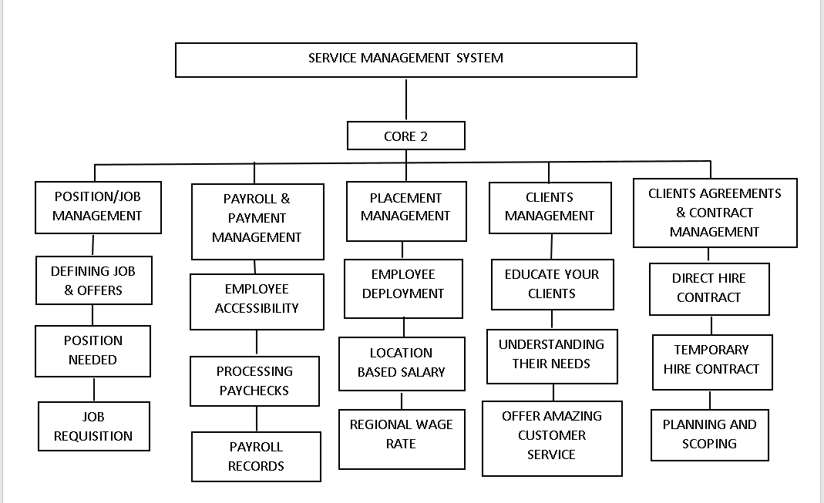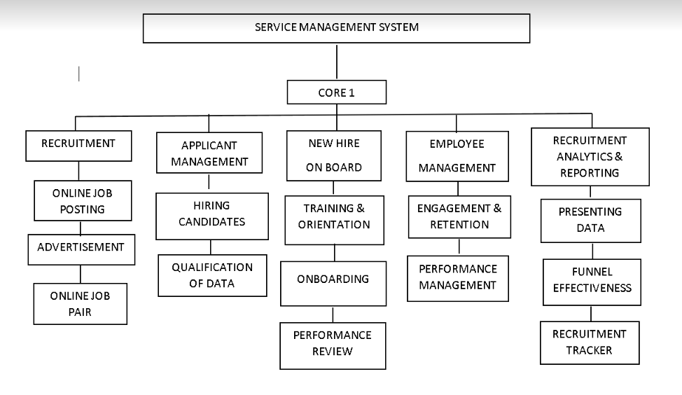

### Scope verification

### Scope control

# Project Execution plan

## Implementation and migration plan

### Purpose

### Description of implementation

### Points of contact

### Major task

### Implementation Schedule

### Security

### Implementation Support

### Listing of hardware, software and facilities

### Performance Monitoring

### Implementation Requirements (Hardware/Software/ Personnel/ Facilities/ other capital investment:

### Back Out Plan

### Post Implementation Verification

# Project Closure

## Transition-out plan

### Executive Summary

To sustain the employment agency’s services, the Service Management System has developed an improved form of core transactions. The technology will be completely operational and will assist the agency in serving and organizing customer information. The development team will implement and authorize the system, which will be done by the agency’s IT department. The contract is presently being discussed and handled, and the system’s operations will take some time to decide.

### Transition Approach

The development team will provide the system and give it on to the core transactions in this case. The staff will test the system, while the development team will oversee its installation,efficacy, and integration. The transformation will take 30 days from start to finish. Prior to the shift, the core transaction will put on hold, and the development team will tackle all issues that arise during the transition. As previously stated, the core will be assigned people at the start of the 30-day transition and will work closely with the team.

### Transition Team Organization

The following chart illustrates the transition team members from Dev Team, (), as well as the roles and responsibilities of each team member.

### Work Transition

All employees will remain with their present employer during this contract transfer. The personnel of the employment agency will stay on standby to complete their transition efforts until the transition is completed and accepted by all parties. Until the transition is complete, the development team will provide workspace for all parties involved.

### Work Execution during Transition

During the transition period of this arrangement, work will be completed by an employment agency in accordance with the approved project timeline and work breakdown structure. The development team will ensure that the core transaction staffs collaborate with the parties involved. However, the employment agency will be in charge of all task and delivery management. Upon transition acceptance will take its position at the end of the 30-day transition period.

### Subcontracts

This section lists all current contracts and whether or not they will be transferred. The chart below shows the subcontracts in place to help with core transactions. These subcontracts use third-party duties to secure all essential transactions and ensure that the system’s functionality is in place.

### Property Transition

#### Government Furnished Equipment (GFE)

As part of the transition, all GFE delivered to employment agencies will be subject to a contract that will be transferred to the government after the transition phase is completed and accepted. GFE is made up of devices like laptops and computers. The government’s information technology officer will assign and issue all electronic gadgets.

#### Incumbent Owned Equipment

Upon completion and acceptance of the transition, all necessary owned equipment will remain with the incumbent. If it is determined that any incumbent owned equipment must remain with the client in order to ensure the successful completion of the contract, the client and incumbent contracting staff representatives will interrelate the acquisition of the equipment through the customer’s confirmed procurement cycle.

#### Intellectual Property

According to the transaction contract, any intellectual property created as a direct result of work on the contract deliverables would be transferred to the new contractor in order to ensure the project’s success. As a result, any generated intellectual property will be owned by the consumer.

#### User Accounts and Passwords

Various user account accesses and authorizations must be created and disabled as part of the contract changeover. Personnel from the employment agencies shown in the chart below currently have the user accounts and access required for contract deliveries. On the first day of the contract changeover phase, the mentioned employment agency personnel will be provided access. All user accounts for employment agency officials will be disabled once the transfer is complete and approved.

### Knowledge Transfer

The knowledge transfer will take place during the 30-day transition period for this transformation. Knowledge will be transferred in a variety of ways. The current PM will help the incumbent IT to organize two formal classroom training sessions. These lectures will concentrate on the unique issues surrounding database duties and activities. The topics covered in these workshops will include documentation requirements and organizational processes. These sessions must be completed at least 1 week before the 30-day transition period ends. Additionally, within the 30-day time, all transactional personnel in employment agency counterparts must get acquaintance with the process. The project manager and the customer will meet no later than one week before the transition is completed to assess if any additional training or knowledge transfer is necessary.

### Schedule

The schedule for transitioning the transaction contract to an employment agency is depicted in the chart below. Any changes to this plan must be communicated to and approved by the client and all other parties.

### Handover and Acceptance

When the transfer is complete, the client will make a decision and sign a document indicating it. To accomplish this, the clients transition project manager will consult the specified transition checklist to determine whether or not all transition-related activities have been completed. The transition project manager will meet the clients transition project manager from each contractor to ensure that all concerns and issues are handled. The checklist and associated documents will be signed and approved by the clients project sponsor and the company’s human resources director once the transition project manager has formally approved the transition. The formal acceptance and signature of the customers contracting officer representative is the final stage. The transition will not be considered complete until all of these approvals and signatures have been received.

## Project acceptance

This document represents the core transition’s formal acceptance of the work items and deliverables. The core transaction met all of the project documents and scope statements acceptance criteria and requirements. All essential deliverables have been tested to ensure that they meet the project’s requirements. The quality and functioning of the product were also assessed and quantified.

The project was turned over to the transaction staff, who were trained on how to utilize it as their new way system. The project’s expertise has been fully transferred. The project manager has been given permission to complete the project’s formal closeout. A post-project evaluation, documentation, project team release, closing out all procurements, and archiving all pertinent project records are all part of the closeout process. The project sponsor will be contacted after the closing procedure has been completed, and the project manager will be dismissed from the project.

## Post project review

### Project Summary

The Service Management System has been moved to the operations cluster for production by the core transaction. The cluster has reached the end of a difficult but fruitful endeavor.

The goal of the service management system is to boost core transaction generation. This project satisfies the need of an employment agency to streamline service management and generate core transactions quickly. Employment system design, all coding, testing, deployment of an integrated system for use with current IT infrastructure and user guide are among the project deliverables. The employment agency’s goals are to improve transactional services, make data collection easier and give reporting capabilities. The project’s high-level risks include ensuring that the implementation is completed without disrupting ongoing employment activities and that there are no problems moving collection files from the legacy system to the new system. After the system has been built and one full transaction cycle has been completed with no discrepancies, the project sponsor will decide success.

#### Project Team and Staffing

|  |  |
| --- | --- |
| **Roles** | **Duties and responsibilities** |
| Adviser | * Advising the team and give another idea to improve our building system and in documentation |
| **Project Manager** | * Managing the team * Monitoring each members and help to motivate the project team |
| System Analyst | * Analyze the workflow of the proposed system * Making schedules for student |
| Business Analyst | * Analyze the business process of the system * Making schedules for the student |
| Programmer | * In charge in developing the system esp. the Coding’s and designing the proposed system |
| Documentation  Specialist | * Responsible in writing the documentation of the system and in making diagram with regard to the system flow and also in creating of schedules for students. |

#### Project Deliverable (Planned vs. Actual)

#### Transition to Operations

### Project Costs

### Project Schedule

### Recommendations

# Technical solution design

## Project Information

## Executive Summary

## Requirement Definition

## Solution Description

### Logical Architecture

### High-Level Architecture

### Process Flow

## Implementation Timeline

# System architecture

## Business Process Architecture

## Application Architecture



## Data Architecture

## Technology Architecture

# Product Backlog

## Product backlog (user stories) Table

## Product Backlog for EIS Information Security

## Product Backlog for EIS Standards

## UI/UX (Icons, color, etc.)

## Product Backlog for integration

## Product Backlog for analytics

## Application System Analytics

## EIS Analytics

# Sprint backlog

## Sprint backlog table

### User stories

### Information security

### EIS standard

### EIS integration

### Analytics

## Sprint Burndown Chart

### Sprint Backlog

# EIS Implementation Model

## Information and Data Management

### Data Integration Model

### Data Migration Strategies

#### Planning

#### Data Profiling

#### Data Backup

#### Migration Design

#### Execution

#### Testing

#### Post-Migration Audit

### Data Analytics (Business Intelligence Framework)

### Privacy and Security

### Backup, Retention, and Disposal

## Information Security

### Physical Security

#### Administrative Security Controls

##### Personnel Security

##### Account Management

#### It and Security Policy

#### Technical Security Controls

##### It Infrastructure Security

##### Software Security Management

##### Cloud Security

##### Cybersecurity

#### Network Security

#### Firewall Management

#### Network Devices Security

#### Software Patch Management

#### Malware Protection

## Network Design and implementation Model

### Design Architecture

#### Hardware

#### Transmission Media

#### Protocols

#### Topology

### implementation Framework

# Conclusion and Recommendations

# Appendices:

## Appendix A Detailed System Architecture/ Reference requirements

### A.1 Business Process Architecture (Business Process Model)

### A.2 Application Architecture

#### A.2.1 UML- Use Case Diagram

#### A.2.2 UML- Detailed Diagrams

#### A.2.3 UI Navigation Diagram

#### A.2.4 UIs (Design Layout)

### A.3 Data Architecture

#### A.3.1 ERD

#### A.3.2 Class Diagram

#### A.3.3 Data Dictionary

### A.4 Technology Architecture

# Appendix B Deployment Diagram

# Appendix C Adviser Acceptance (Functional)

# Appendix D Sprint Burndown Charts (per sprint) Signed by the adviser

# Appendix D.1 Individual burndown charts per member

# Appendix B Deployment Diagram

# Appendix E Requirements Traceability Matrix (PB, Test Scenarios, status

# Appendix F Panel Evaluation and Signature (Plus photo ops during defense)

# Appendix G Pilot Companies Background with proofs of interviews

# Appendix H USB Copy of the codes (reliable USB)

# Appendix I IMRAD Format Summary

# Appendix J Comparison of the EIS to existing EIS’s (5 Pages)

# Appendix K Operation Manual (10 Pages max, 5 Pages min)

### 